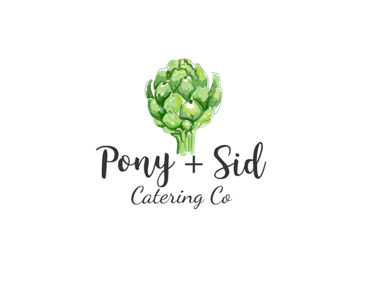

Christmas 2021
Order form
Let us help make your Christmas festivities a little easier.
We have a few goodies to add to your usual family favourites! All items that require heating will have cooking instructions.
Orders forms are to be filled and sent back by Monday 13th of December. Pick up’s will be on Thursday 23rd of December ONLY between 9am & 1pm. Collection at 9/33 Benison Rd, Winnellie.
Orders aren’t confirmed until paid.
Merry Christmas, love the Pony + Sid team x
Name: |  | Contact Number:
Email: |  | Pick up time:
Item | Cost | Quantity | Total
Salmon mascarpone dill & caper dip w garlic crackers  Serves up to 5 | $16
Mustard & marmalade glazed Christmas Ham - ½ leg (roughly 4.5-5kg)  Cooked- Served warm or cold | $140
Half roasted side of salmon w macadamia crumb labne herb garnish  Cooked, served warm or cold | $60
Potato salad w crispy bacon dill beans & egg  Serves up to 8 | $60
Cauliflower & broccoli gratin w parmesan & garlic crumb  Serves up to 6 | $40
Antipasto Box  Soft brie, manchego, gorgonzola, salami, cherries, our gf brownie, crackers, vine tomato’s, house olives, quine, hummus, labne, & nuts  Serves up to 8 | $100
Tomato chutney | $9
Labne | $9
Rum Balls (8) | $25
Melting moments (9) | $40

Payment Details OR call to pay over the phone by Monday 13th
Name on card: _____________________________
Card Number: _____________________________
Expiry: _____/_____
CVV: ___
Pony + Sid
0450524819
ponyandsid@gmail.com
www.ponyandsid.com

